## Setting a budget

### Activity Diagram

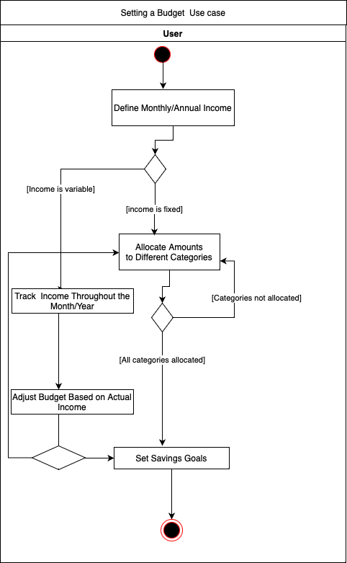

### Activities

* + 1. Activity starts.
    2. Users define their monthly or annual income.
    3. A decision point asks if the income is fixed or variable.
    4. The user then allocates specific amounts to different budget categories (e.g. Rent, Groceries, Entertainment, etc.).
    5. A decision point checks if all categories have been allocated. If "No", the user returns to category allocation. If "Yes", they proceed.
    6. After allocating for all categories, the user sets savings goals.
    7. If income is variable, the user will need to track their actual income throughout the month or year.
    8. The user adjusts the budget based on the real income figures. This might involve reallocating amounts to different categories or adjusting savings goals.
    9. The activity ends.

### Entities, attributes

| Entity | Description | Attributes | Example |
| --- | --- | --- | --- |
| User | Contains user details | UserID,Name,Email | UserID: 101  Name: "John Doe"  Email: "johndoe@email.com" |
| Budget | Contains budget details | BudgetID,UserID,Month,Year,TotalIncome,TotalExpenses | BudgetID: 2023  Month: 10 (October)  Year: 2023  TotalIncome: $5000.00  TotalExpenses: $3200.00 (This would be calculated based on the expenses added to this budget.) |
| Category | Different categories | CategoryID, Name | CategoryID: 1  Name: "Groceries" |
| Expense | Contains user expenses | ExpenseID,BudgetID, CategoryID, Amount, ExpenseDate | ExpenseID: 456  Amount: $150.00  ExpenseDate: "2023-10-05" (5th October 2023)  Category: "Groceries" (This would be set using the categorizeExpense method.) |
| Goal | Contains user goals with realistic timelines. | GoalID, UserID, Name, Amount, Deadline | GoalID: 789  Name: "Save for Vacation"  Amount: $2000.00  Deadline: "2023-12-31" (31st December 2023) |

### ER Diagram

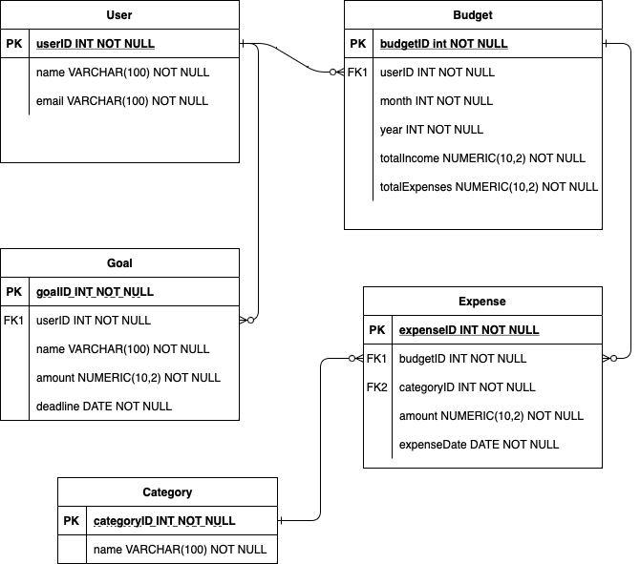

### Relationships

* + 1. User - Creates -> Budget
       1. One User can create multiple Budgets, but each Budget is created by one User.
    2. Budget - Contains -> Expense
       1. One Budget can contain multiple Expenses, but each Expense belongs to one Budget.
    3. Expense - Belongs to -> Category
       1. One Expense belongs to one Category, but each Category can have multiple Expenses.
    4. User - Sets -> Goal
       1. One User can set multiple Goals, but each Goal is set by one User.

### Class Diagram